Dried Bacon Fat

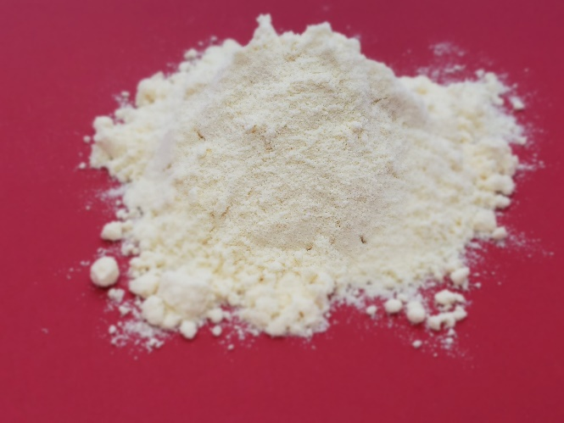

Dried Bacon Fat is a high quality pet food ingredient produced by co-drying bacon fat with dairy ingredients. Dried Bacon Fat has a pleasant, distinctive bacon aroma and may be added as a nutritive palatability enhancer for pet foods. Typical inclusion levels are 1-10% either as a coating or within the formulation mix.

Features:
- Great bacon aroma for pet foods and treats
- High quality dairy protein and fat
- Powder to coat topically or mix into formulas evenly
- Produced from real bacon drippings
- Produced in SQF- and EU-audited facility

