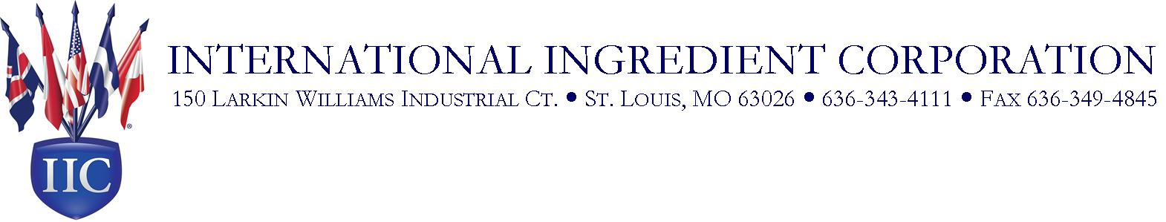

Dried Cheese Uncolored
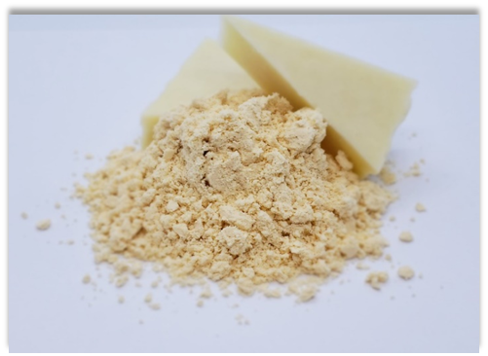
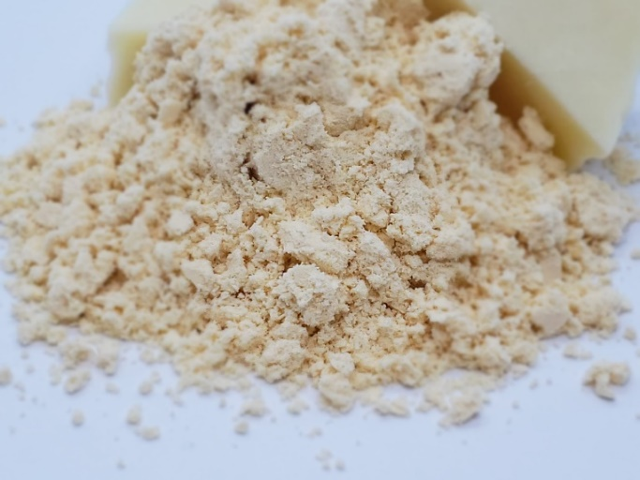

Dried Cheese Uncolored is a high quality pet food ingredient produced by spray-drying cheese. Dried Cheese Uncolored is an excellent source of milk proteins and milk fat for any animal. Dried Cheese Uncolored may be added as a nutritive palatability enhancer for pet foods. Typical inclusion levels are 1-10% either as a coating or within the finished formulation mix.

Features:
- Great cheesy aroma for pet foods and treats
- High quality dairy protein and fat
- Powder to coat topically or mix into formulas evenly
- Produced from cheese trimmings, ends, and pieces
- Great sustainable source of cheese for pet foods and treats
- Produced in SQF- and EU-audited facility

