PalCrave® NP Y4318L

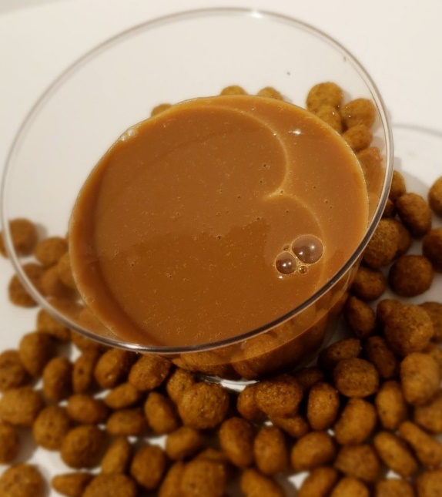

PalCrave® NP Y4318L is a unique liquid hydrolyzed yeast-based palatant with a smooth, toasted yeast aroma that is stable at room temperature. Independent testing has demonstrated proven palatability against other high quality liquid palatant products that are animal liver- and yeast-based. PalCrave® NP Y4318L can be coated topically at 1-5% of the product or added internally to a dry or wet product.

Features:
- Hydrolyzed yeast-based palatant
- Hypoallergenic
- Pleasant toasted yeast aroma
- Research proven palatability
- Non-GMO
- No animal-origin ingredients
- Manufactured in the USA (Monett, MO)
- Liquid product available in bulk, totes, and drums
- Palatability as good as or better than other commercial liver- and animal-based palatants
- Shelf stable at room temperature

